Rapid review of Kenya/ county mangrove cover trends based on Global Forest Watch products.

**Prepared by James Mbugua; CORDIO EA 15th May 2018**

**Email:** [**jmbugua@cordioea.net**](mailto:jmbugua@cordioea.net)

Table of Contents

Objectives 1

Materials and method 1

Data access and processing 1

Results 4

Cover change 4

Mangrove cover extent in Hectares per county 5

## Objectives

1. To conduct a rapid estimate of the current National and County mangrove cover and cover trends using 1992 mangrove cover surveys/layers as baseline area of interest
2. To evaluate the suitability of Global Forest Products and algorithms in estimating Mangroves cover trend for use in the OHI+ Kenya biodiversity goal assessment. (sees goals and models http://ohi-science.org/mhi/goals.html#reference_points48)

## Materials and method

This study entails a rapid desktop review of Kenya’s national and county mangrove cover trends based on the Global Forest Watch forest products (GFW) available here: <https://www.globalforestwatch.org/map/3/15.00/27.00/ALL/grayscale/loss,forestgain,forest2000?tab=analysis-tab&begin=2001-01-01&end=2017-01-01&threshold=30&dont_analyze=true>

Global Forest Watch (GFW) is an online platform that provides data and tools for monitoring forests. By harnessing cutting-edge technology and algorithms, GFW allows for open access of near real-time data about where and how forests are changing around the world.

Currently, the online portal does not discriminate between forest type and thus the process of delineating specific ecosystems such as pure mangrove stands are not directly forward. However, algorithms developed with the system make it possible to conduct an exploratory analysis. Such analysis have been used in various parts of the world to justify management priorities for specific ecosystem i.e. mangroves in Philippines and <http://www.congress.gov.ph/press/details.php?pressid=8604>. and Madagascar.

### Data access and processing

GFW portal provides exploratory tools for quantifying alerts or hectares inside polygons that can be drawn by hand or uploaded as custom GIS shape files provided the layer/vector polygon does not exceed 1mb. We capitalized on this feature to estimate Kenya’s National and County mangrove cover from 2001 to 2016.

To define the vector polygon for the analysis, we sourced 2010 mangrove layer to use as baseline data from the WCMC archive and derived the extent/area of Mangrove cover for Kenya. The 2010 Mangrove global layer reports Kenya’s mangrove cover from 1992 surveys conducted by Kenya Wildlife Service. The data was provided for publication by Taylor et al (2003).

Kenya/County mangrove spatial extents were derived from the global 2010 layer through intersecting and spatial sub-setting. Each layer was then exported as standalone zip files for each county and used as primary products for input into the analysis process.

The spatial results were generated by sampling the selected area defined by the uploaded vector polygons (2010 Mangrove cover layer). Annual values (cover loss) were generated by moving the slider between years’ **fig 1**, below and values recorded for each county in a matrix shown in **table 1** (Note: The table has been transposed to fit vertically. You may copy and transpose it horizontally for an alternative view).

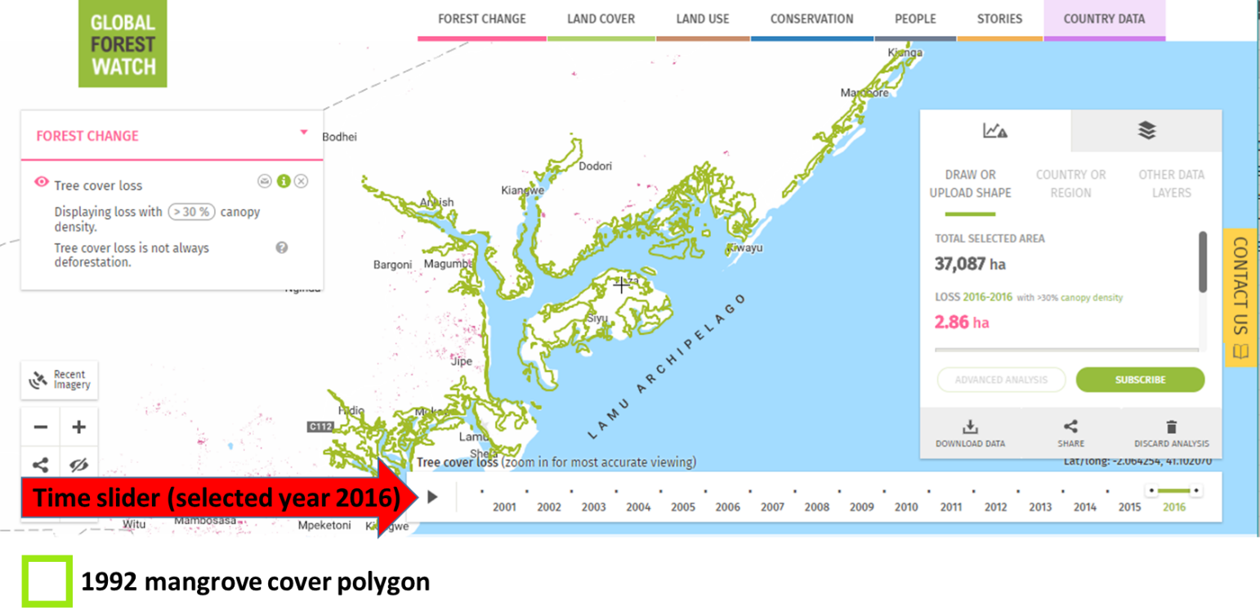

Figure 1 Screen shot of the GFW mapping tool showing Lamu county area of interest (defined by mangrove polygon from 1992 surveys) and the time slider

Table 1 Table showing mangrove cover loss values by County per year and total mangrove cover loss (red) and gain (Blue)

|  |  |  |  |  |  |  |  |
| --- | --- | --- | --- | --- | --- | --- | --- |
|  | **County** | **Kilifi** | **Kwale** | **Lamu** | **Mombasa** | **Tana River** | **National Totals** |
| Baseline Year & cover Ha | **1992** | **6,355** | **8,056** | **37,087** | **3,708** | **6,154** | **61,360** |
| **Mangrove cover loss/year** | **2001** | 0.09 | 3.48 | 0.8 | 1.43 | 0.63 | **6** |
| **2002** | 0.36 | 1.43 | 0.18 | 2.85 | 5.89 | **9** |
| **2003** | 2.94 | 1.87 | 8.76 | 3.66 | 0.54 | **16** |
| **2004** | 3.75 | 9.45 | 0.45 | 1.07 | 3.04 | **17** |
| **2005** | 0.09 | 1.78 | 5.18 | 0 | 3.57 | **11** |
| **2006** | 5.09 | 2.85 | 3.48 | 2.32 | 4.64 | **16** |
| **2007** | 1.07 | 6.59 | 6.88 | 1.96 | 1.34 | **11** |
| **2008** | 1.07 | 5.7 | 2.59 | 0.18 | 4.02 | **14** |
| **2009** | 0.98 | 8.82 | 4.38 | 1.16 | 5.36 | **12** |
| **2010** | 12 | 10 | 0.80 | 0.62 | 10 | **23** |
| **2011** | 0 | 3.39 | 0.18 | 0.18 | 1.88 | **2** |
| **2012** | 2.59 | 13 | 5.09 | 3.83 | 4.02 | **29** |
| **2013** | 3.66 | 9.62 | 34 | 4.37 | 2.14 | **16** |
| **2014** | 13 | 82 | 63 | 8.20 | 6.88 | **158** |
| **2015** | 0.18 | 2.67 | 6.34 | 0.54 | 3.93 | **13** |
| **2016** | 0.18 | 2.76 | 2.86 | 1.07 | 2.95 | **4** |
| Total loss | **2001-2016** | 43.39 | 137.05 | 99.98 | 24.7 | 51 | **356** |
| Total gain | **2001-2012** | 0.27 | 7.6 | 2.32 | 0.54 | 0.8 | **11** |

## Results

### Cover change

Comparison of Mangrove cover across all counties depicts an upward trend in mangrove cover loss between 2001 and 2016 with the bulk of the loss recorded in the year 2014 in all coastal counties.

Figure 2 Mangrove cover loss per county between 2001 and 2016

The total national loss over the 16-year period is estimated at 356 hectares.

Kwale county lost a total of 137 hectares the highest when compared with other coastal counties **figure 3a**. However, the county also gained some significant amount i.e. 7.6 hectares of mangrove between 2001 and 2012 again the highest when compared with other coastal counties **figure 3b.**

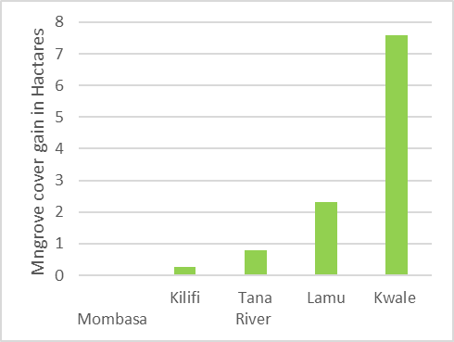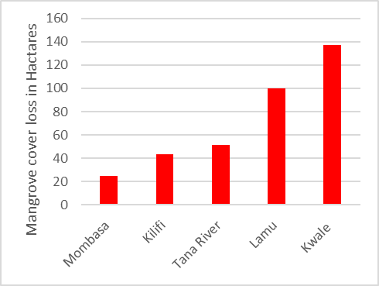

**b)**

**a)**

Figure 3a) Mangrove cover total loss between 2001 and 2016 (3b)Mangrove cover total gain between 2001 and 2012

## Mangrove cover extent in Hectares per county

To derive mangrove, cover extent/area in ha per year per county, we calculated the difference between the area of mangrove cover for the baseline year 1992 and total loss in mangrove cover in 2002 in hectares using the formula

*New mangrove cover for Year x (i.e. 2001) =Mangrove cover in hactres for the baseline year (i.e. 1992) - Amount in hectares of mangrove cover loss for the year in question (i.e. 2001)*

Same approach was used to derive the mangrove cover for subsequent years’ **table 2**. Note that the new mangrove cover derived for each year defined the new baseline year for the succeeding year.

|  |  |  |  |  |  |  |  |  |  |  |  |  |  |  |  |  |  |
| --- | --- | --- | --- | --- | --- | --- | --- | --- | --- | --- | --- | --- | --- | --- | --- | --- | --- |
| **Mangrove Extent per county (hectares)** | | | | | | | | | | | | | | | | | |
|  | **1992** | **2001** | **2002** | **2003** | **2004** | **2005** | **2006** | **2007** | **2008** | **2009** | **2010** | **2011** | **2012** | **2013** | **2014** | **2015** | **2016** |
| **Kilifi** | 6535 | 6534.91 | 6534.55 | 6531.61 | 6527.86 | 6527.77 | 6522.68 | 6521.61 | 6520.54 | 6519.56 | 6507.56 | 6507.56 | 6504.97 | 6501.31 | 6488.31 | 6488.13 | 6487.95 |
| **Kwale** | 8056 | 8052.52 | 8051.09 | 8049.22 | 8039.77 | 8037.99 | 8035.14 | 8028.55 | 8022.85 | 8014.03 | 8004.03 | 8000.64 | 7987.64 | 7978.02 | 7896.02 | 7893.35 | 7890.59 |
| **Lamu** | 37087 | 37086.2 | 37086.02 | 37077.26 | 37076.81 | 37071.63 | 37068.15 | 37061.27 | 37058.68 | 37054.3 | 37053.5 | 37053.32 | 37048.23 | 37014.23 | 36951.23 | 36944.89 | 36942.03 |
| **Mombasa** | 3708 | 3706.57 | 3703.72 | 3700.06 | 3698.99 | 3698.99 | 3696.67 | 3694.71 | 3694.53 | 3693.37 | 3692.75 | 3692.57 | 3688.74 | 3684.37 | 3676.17 | 3675.63 | 3674.56 |
| **Tana River** | 6154 | 6153.37 | 6147.48 | 6146.94 | 6143.9 | 6140.33 | 6135.69 | 6134.35 | 6130.33 | 6124.97 | 6114.97 | 6113.09 | 6109.07 | 6106.93 | 6100.13 | 6096.2 | 6093.25 |
| **National Totals** | 61360 | 61354 | 61345 | 61329 | 61312 | 61301 | 61285 | 61274 | 61260 | 61248 | 61225 | 61223 | 61194 | 61178 | 61020 | 61007 | 61003 |

Table 2 Mangrove cover extent per county (hactares)